Carrollton Kiwanis
Newsletter
August 23, 2021 | Serving the Children of the World

Officers  President: Bill Bollinger  Pres.-Elect: Tracey Wozny  Vice President: Jeff Adams  Secretary: Ron Schuler  Adm. Treasurer: Robert Pavlu  Act. Treasurer: Norm Bliss  Past Pres.: Jay Wilson  Lt. Gov. Greg Atkins, Smithville  Board of Directors  Jerene Barnett  Andy Kelb  Stacy Adams  Marty Rucker  Blake Riley  Jeff Tindle  Facebook  @carrolltonmokiwanisclub  Websites  Kiwanis.org  Moarkkiwanis.org  div3kiwanismoark.weebly.com  August Birthdays  Earl Austin, 21  Sandra Garcia, 21  Linda Leabo, 19  David Martin, 2  Loretta Minnis, 31  Bob Mulch, 15  Robert Pavlu, 26  Fred Phillips, 19  Monthly Youth Meetings  Key Club  1st & 2nd Friday of month, 7:30 AM  Builders Club  2nd Wednesday of month, 3:05 PM  Terrific Kids Assembly  Awards given each month  Publications Editor  Ron Schuler | An evening meeting was held by the Carrollton Kiwanis Club on Monday, August 23, 2021. Twenty members and one Key Club member, Ruby Schmidt, were in attendance. Gail Thurlo and Robert Pavlu led the pledge and prayer, respectively. Everyone enjoyed a well-prepared dinner by Earlene Martin, which consisted of tender boneless pork chops, mashed potatoes and gravy, creamed peas, tossed salad, hot rolls, and a pecan pie brownie with vanilla ice cream on top. Meals like this you only dream about!  As we were eating, Tracey Wozny presented a short program on the mental health of children in today’s society. She explained that the National Health Crisis eight years ago related to adults and child obesity; today it is stress and anxiety related. In five years, the prediction is substance abuse. She went on to explain how our club could help take action, and how every individual can listen to them, ask questions, lead from the side, tell stories, and give them ownership in projects. The club appreciated Tracey’s presentation and concern for our children in our community.  The business meeting began with an introduction of Key Clubber Ruby Schmidt by their advisor, Jeri Burger. Ruby is vice-president of the club and Lieutenant Governor of their district (Richmond, Trenton, Marshall, Chillicothe, and Carrollton). Ruby explained that their club started with projects in July with a donation of money to Life Care, as well as purchasing school supplies for our elementary students. Other events this fall include selling snow cones at Band Day, and a district Fall Rally in Carrollton on November 13. In October they plan a shoe and sock drive, a coat drive in December, and later in the year they plan on attending the MO-Ark District Key Club Convention. The Key Club has gotten off to a great start this year. They meet on the first and second Fridays of each month at 7:30 AM in the high school art room.  Earlene Martin reminded the club that we have no more meetings before our first home football games, September 3 & 10, and Band Day, September 25, to sign up for the concession stand. If everyone that signed up and with the help of Key Club, we should be able to handle the customers. Earlene commented that supplies were not easy to purchase this year, due to some shortages, but through careful planning and clever substitutions , the concession will go on. Thanks, Earlene and David ,for your time and dedication to making the concession stand a success.  Jim Gibson, golf committee chair, reminded the membership that September 13 was the club’s all-day golf tournament at the Carrollton Country Club. Help is needed on Sunday, September 12, at 4:00 PM to set sponsor signs around the course and in the club house. Additional help is needed on the day of the tournament. There is still room for golf players to sign up. Bill Bollinger has player forms, and he may be contacted at the Carrollton Hospital.  Randall Barry and Stacy Adams talked about the Kids Day Parade, Saturday, October 30, the day before Halloween. They are planning an organizational meeting at the Country Club, on Thursday, September 9, at 5:00 PM. Any Kiwanis member is invited to attend. This event has been a huge success in the past, and they anticipate the same for this third year.  Randall continued by sharing a thank you banner that was signed by the Terrific Kids at their End-of-Year Celebration last Spring. The celebration was divided over two days, K-2 and 3-4 grades, for two hours of fun outside with refreshments, face painting, jump rope, and many other games. The Kiwanis Club is grateful to sponsor the Terrific Kids program, and they are equally thankful for all the work that coordinator Piper Barry and the elementary teachers and staff do that make this program a success.  The Kiwanis meeting scheduled for September 27 has been cancelled; however, a special meeting will be held on Monday, September 20, at noon, to prepare for Band Day.  Stay safe and have a great week.  Future Programs, 2021  Sep 13 – Noon Meeting at Country Club, Golf Tournament  Sep 20 – Noon Meeting  Oct 11 – Noon, Regular Meeting  Oct 25 – 6:30 PM, Regular Meeting/ Board Meeting  Future Activities  Sep 3 – Carrollton Home Football Game, Concession Stand  Sep 6 – Flag Service, Labor Day  Sep 10 – Carrollton Football Game, Concession Stand  Sep 11 – Flag Service, Patriot Day  Sep 13 – Tony Buban Memorial Golf Tournament  Sep 25 – Carrollton Band Day  Oct 1 – Terrific Kids Assembly, 8:15 AM, Elementary Gym  Final Thought  If you don’t know where you are going, any road will get you there.  Lewis Carroll  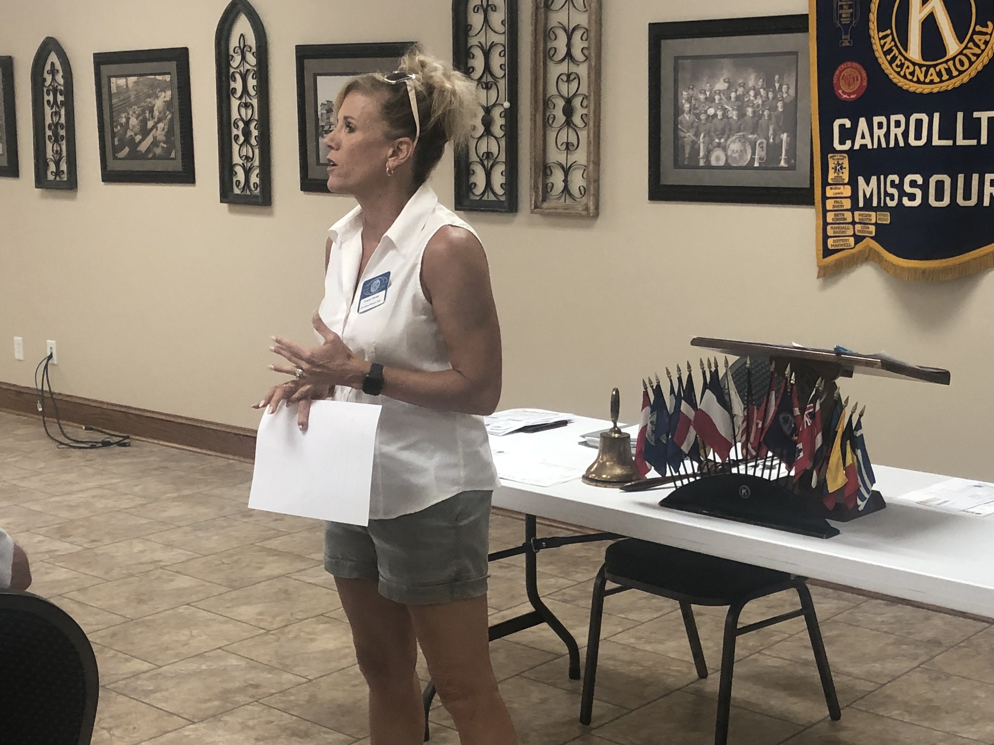  Tracey Wozny talking to members about teens and leadership  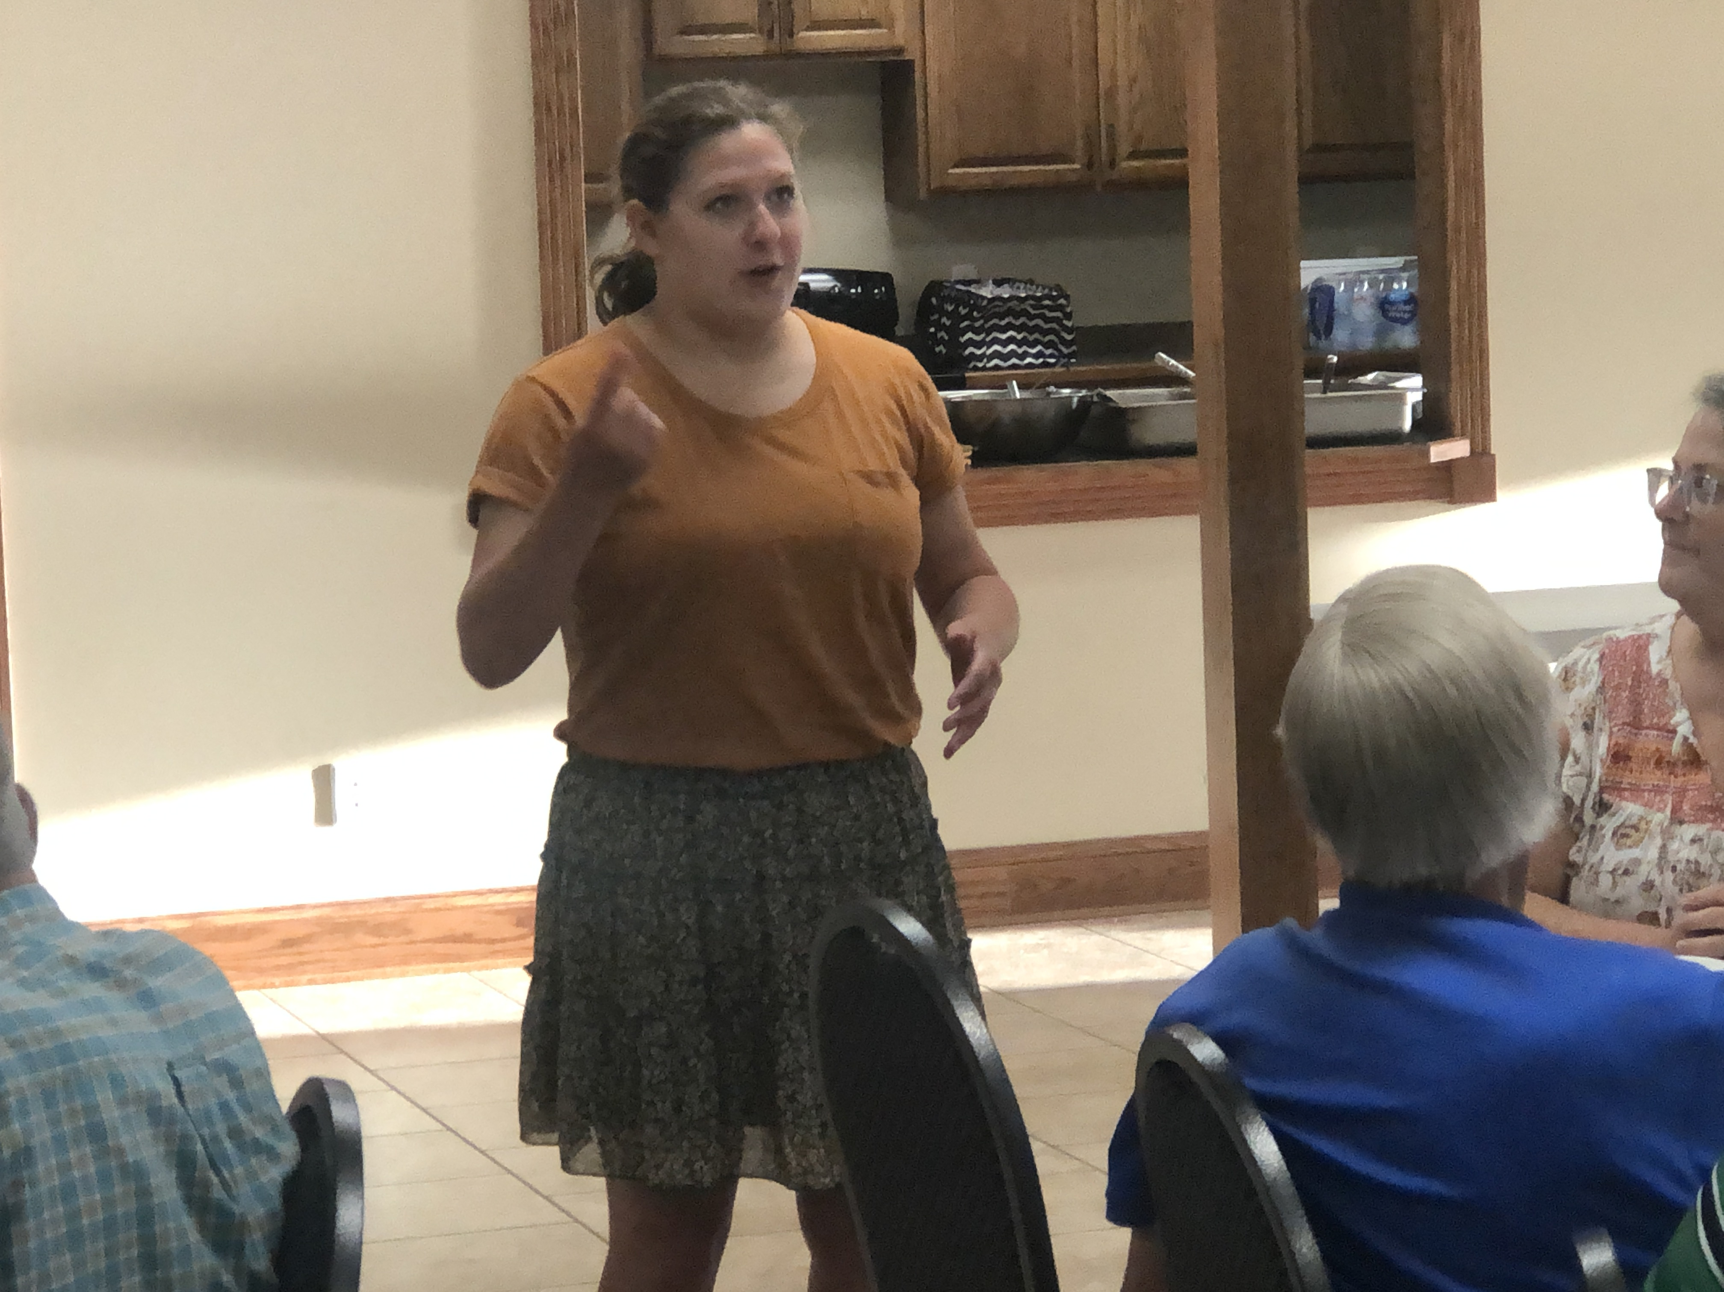  Ruby Schmidt telling members what Key Club is doing this year  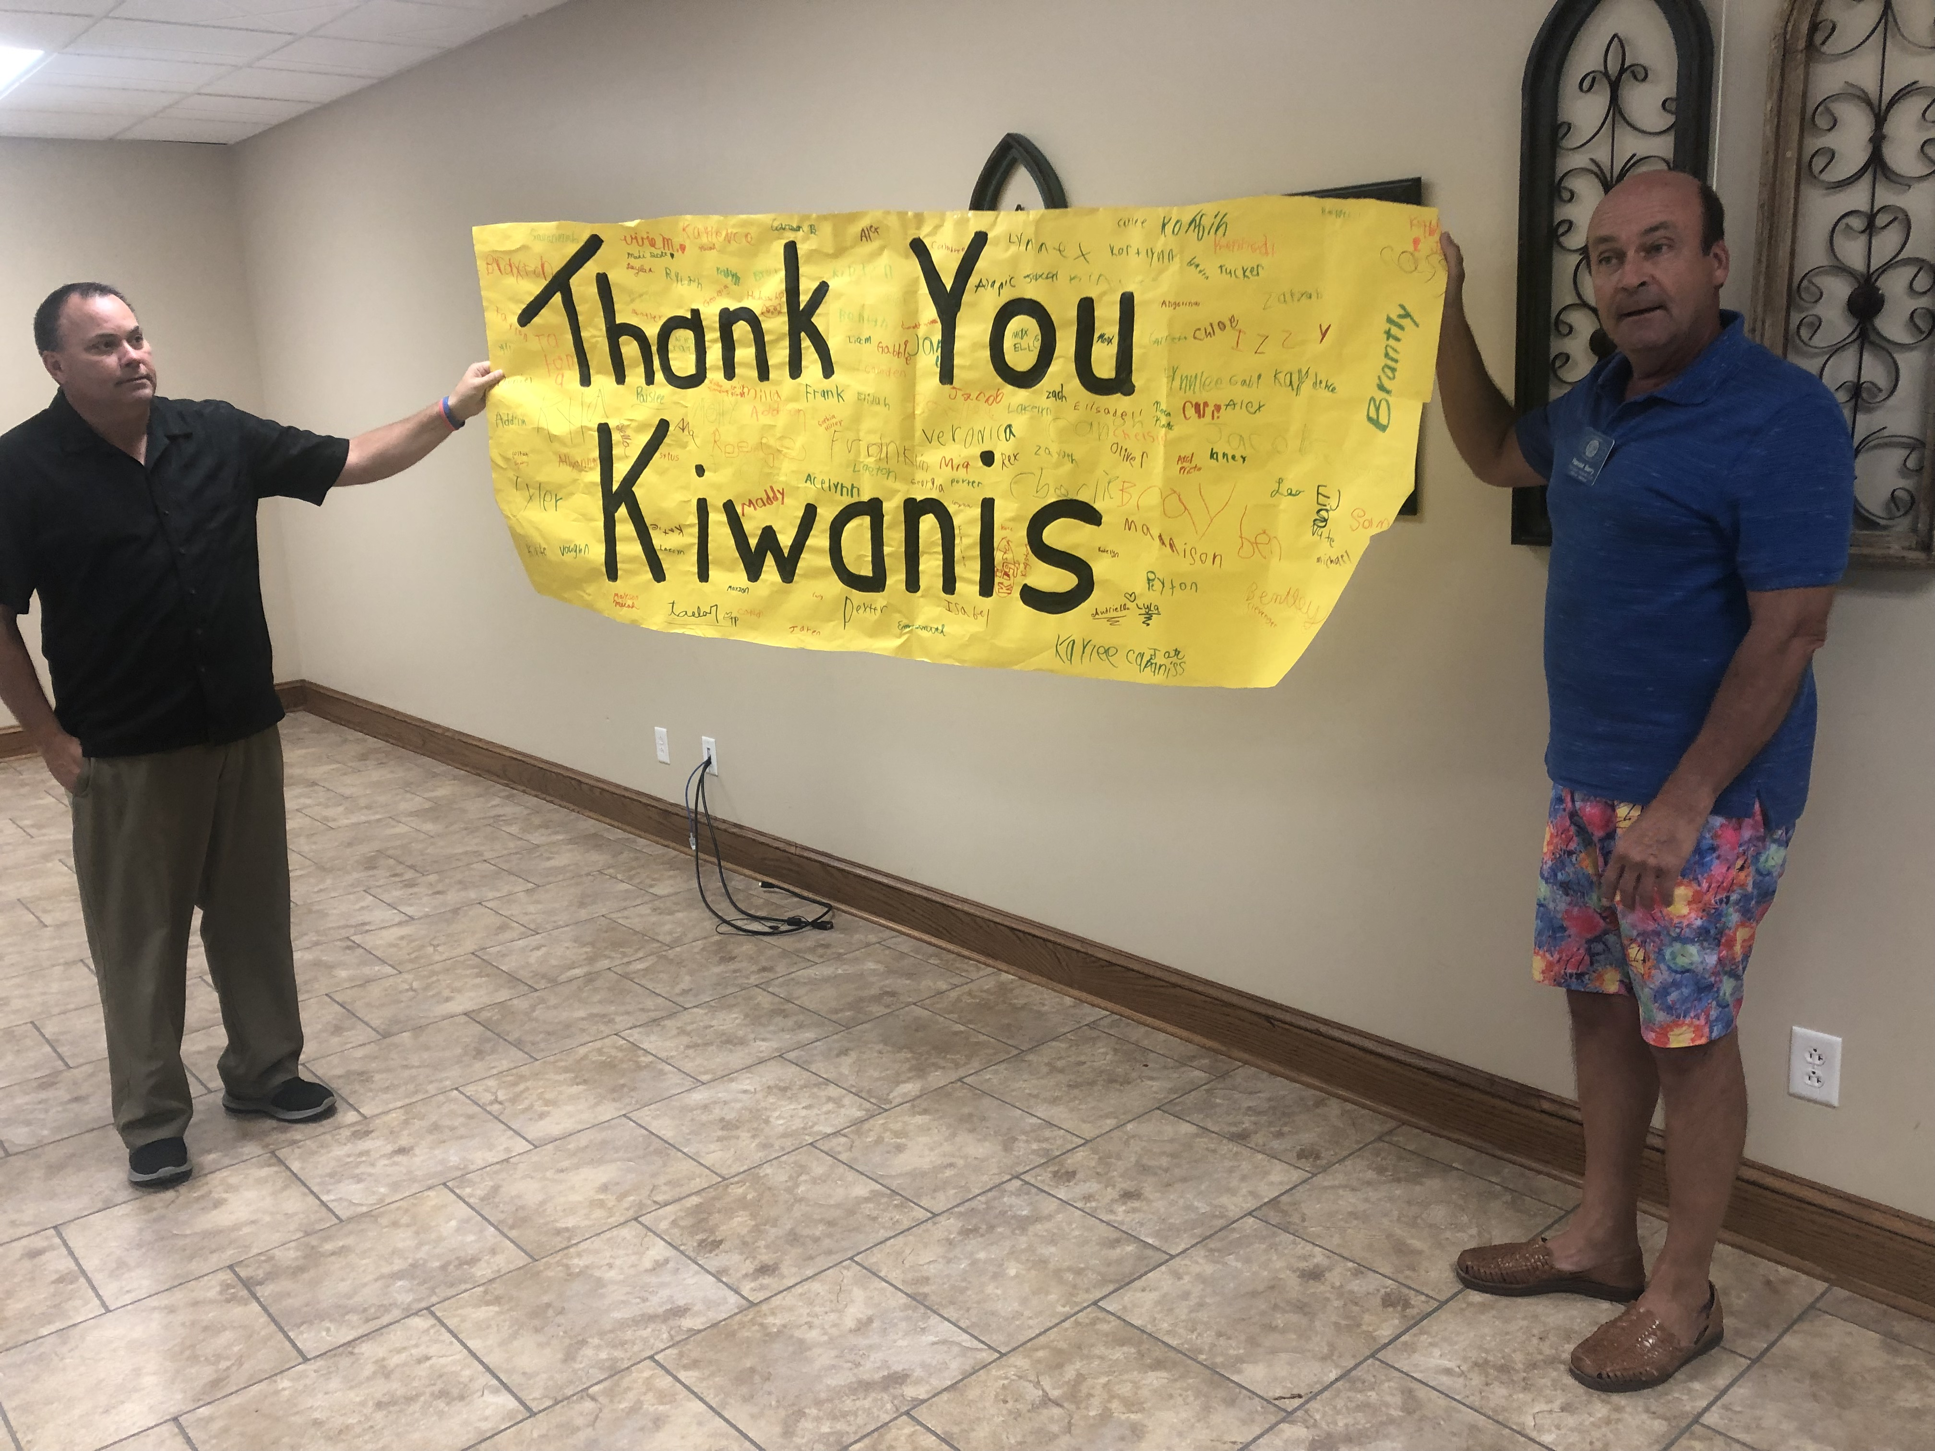  Bill Bollinger and Randall Barry holding sign made by Terrific Kids

