

**Supporting organizations and assisting children**

**in our community and around the world, including:**

Angels’ Arms Destination Desserts Ready-to-Learn St. Louis

Baskets of Hope Nurses for Newborns Ronald McDonald House

CHADS Coalition Our Lady’s Inn Sweet Celebrations

Circle of Concern Project Peanut Butter Toys for School Kids

**Supporting and building student leaders through:**

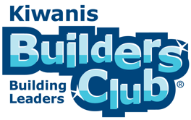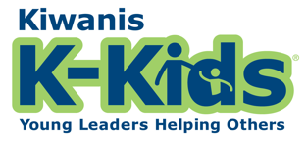

**Elementary Grades: 1-5 Middle School: Grades 6-8 High School: Grades 9-12**



**Supporting organizations and assisting children in our community**

**and around the world, including:**

Angels’ Arms Destination Desserts Ready-to-Learn St. Louis

Baskets of Hope Nurses for Newborns Ronald McDonald House

CHADS Coalition Our Lady’s Inn Sweet Celebrations

Circle of Concern Project Peanut Butter Toys for School Kids

**Supporting and building student leaders through:**



**Elementary Grades: 1-5 Middle School: Grades 6-8 High School: Grades 9-12**